**Airline Backend System**

**Objective:**

We need to build a backend system that support different features for an airline company.

Our end user is going to be someone who wants to book a flight and query about the flights

so we need robust system to give them best experience possible. This doc is solely going to focus on

backend part of application

**Requirements:**

* A user should be able to search flight from one place to another.
  + - User should be able to mention source and destination details.
    - User should be able to select date of journey.
      * [V2] User should be able to search for return flights and multi city.
    - User should be able to select the class of the flight [Non mandatory].
    - User should be able to select the number of seats they want to book [Non mandatory].
    - Now based on above data we will list down the flights.
    - We should show our users the based available flights at the top based on time or money.
    - We need to support pagination support.
    - We should support filters of flight based on Price, departure time and duration.
      * [V2] We can add support for more filters.
* A user should be able to book the flight based on user is registered on the platform.
  + - User should be able to cancel the flight and then based on some criteria we can initiate refunds to them.
    - User should be able to request and book excess luggage for every flight.
* For booking the user has to make a payment[dummy].
* Tracking price should be possible so that user is notified about any price drop or any delay.
* User should be able to list their previous and upcoming flights.
* User should be able to download Boarding pass if they have done online checking.
* Online checking mechanism should be supported.
* Notification via email for completing online check-in before 3 hours of departure.
* Notification to users about any flight delays.
* User should be able to authenticate to our system using email and password.
  + [V2] Support ticketing, where user can raise their queries.
* User should be able to review the flight journey if and only if they have booked the flight.
  + Review mechanism should involve star rating along with comments.
  + While listing any flight we should also display the review of flight.
* Listing FAQ which will be static data.
  + [V2] prepare seat selection.
* Coupons for discount and offers.
* While making booking a person can reserve more than one seat with one login

**Non Functional Requirements**

* We can expect that we are going to have more flights searches than flight bookings.
* The system needs to be accurate in terms of booking.
* Expect that we will be having approx. 1,00,000 total users 5,00,000 booking might come up in one quarter.
* So in one day we can expect 10,000 bookings.
* System should be able to scaling up to at least 3x times the current estimated traffic
* The system should handle real time updates to flight prices, before user makes the final booking
* Concurrency should be handle, using RDBMS should be good solution

**Capacity Estimation**

* Storage estimation-
  + - For upcoming 5 Years, 80,00,000 Bookings, 2,00,000 users considering all the users records and booking records take 10 MB of data then overall 10 TB of memory should be fine for our initial pilot run.
* Traffic estimation - If we consider 10:1 as the search : booking data ratio, then at max we expect 50000 search queries a day . 2 query/s.

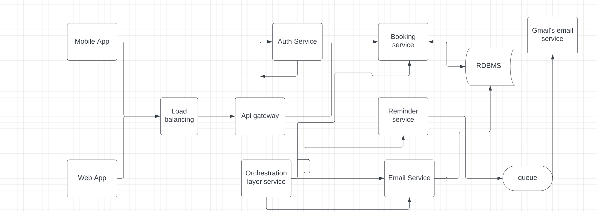

**Search And Flights Service**

* Create flights
* Delete flights
* Update flights
* Search flights
  + Based on multiple filtration criteria we can search flights
  + Pagination

